ARM Firmware Specification
Media Processing Division

Document Number: | GENC-010033 4.3
Date of Issue: | 03 August 2010
Author(s): | David Brash, Jon Callan
Authorised by: | Not Issued
© Copyright ARM Limited 2010. All rights reserved.
1 Introduction 3
2 Firmware Features 4
2.1 Design Goals 4
2.2 Development phases 4
2.3 Changes in version 1.1 4
2.4 Future plans 4
2.5 Architecture licensees 4
3 Firmware Specification 5
3.1 Firmware structure 5
3.2 How the OS uses the firmware 5
3.2.1 Firmware Tables 5
3.2.2 Entry point in Phases 1 and 2 5
3.2.3 Entry point restrictions 5
3.2.4 Phase 1 firmware support 6
3.2.5 Phase 2 firmware support 6
3.3 Firmware tables 7
3.3.1 Master table 8
3.3.2 Cluster table 9
3.3.3 CPU table 10
3.4 Initializing the firmware 11
3.5 Using the firmware from the OS 12
3.5.1 Example C-style pseudo-code 13
3.5.2 APPF_INITIALIZE 14
3.5.3 APPF_POWER_DOWN_CPU 15
3.5.4 APPF_POWER_UP_CPUS 16
3.6 Platform API 17
3.7 Error codes 18
4 Appendix: Overview of Power management 19
4.1 Overview 19
4.2 A typical power-management system 19
4.3 Levels of shutdown 21
4.3.1 Power saving states - general 21
4.3.2 Cluster, CPU and Sub-unit power states 23
4.4 CPU and sub-block power state transition diagrams 23
4.5 Dormant mode, caches and coherency 25
4.5.1 ARM policy and dormant resources 25
4.6 Power gating and the Security Extensions 25
4.6.1 Effect of the CP15SDISABLE input 25
4.7 Jazelle support 26
4.8 Debug support 26
4.9 Performance monitor support 26
5 Appendix: The Context Save and Restore Code 27

Introduction
The ARM Power Firmware is reference software for saving and restoring CPU/cluster context. It is intended to enable an ARM processor-based system to transparently power off its CPUs when it is idle.

This document is written for
- Architecture Licensees and System on Chip designers who are implementing power-saving hardware features
- Operating System vendors who are considering how to implement power-saving functionality in a common way across several hardware platforms
- Software developers who are implementing power management algorithms

Firmware Features

Design Goals
The ARM Power Firmware:
- Is independent of the Operating System
- Provides to the Operating System an abstraction of the power-saving features of the hardware platform
- Supports uniprocessor and multiprocessor configurations on ARMv7-A
- Is loaded and initialized by the system’s boot loader.
- Provides run-time services to power down/up CPUs
For a multiprocessor cluster, the firmware:
- Ensures memory coherency as individual CPUs enter and leave the cluster

Development phases
Phase 1 implemented the API described in section 3, with limited documentation and testing.
Phase 2 will add support for other toolchains and CPUs and improve the documentation and testing.

Release notes for version 1.1
Release 1.1 of the firmware is a Phase 1 release, but has the following changes:
- Builds with the GNU gcc toolchain as well as ARM RVCT – use “make GCC=TRUE”
- Supports flat-mapped operation for bare-metal testing
- Many fixes and changes to save/restore algorithm as a result of testing
- Addition of ready-reckoner spreadsheet to estimate save/restore times
Release 1.1 has the following issues:
- gcc build only works flat-mapped due to an issue with position-independent code generation

Future plans
ARM intends to extend the firmware to provide:
- Support for the ARMv7-R profile
- Support for TrustZone systems running secure services and/or a hypervisor
- Support for other ARMv7-A cores
The firmware will be built with Privileged, Monitor mode and Hyp mode components as appropriate. The firmware entry point will determine where it is executing in the privilege hierarchy (implicitly or explicitly as appropriate) and handle the necessary interaction between privilege levels.

Architecture licensees
The firmware is intended to be an architecture support framework that provides a consistent software interface for power saving. While the firmware is developed against ARM implementations, it is a design goal that it can be easily modified for use by ARM architecture licensees to support their implementations of ARMv7-A and -R.

Firmware Specification

Firmware structure
The firmware is built as a position-independent ELF file. It is loaded by the boot loader, which then calls the boot-time initialization function. The firmware remains present in memory during the OS boot process.

How the OS uses the firmware
The OS is told where the firmware is by the boot loader. The OS maps the physical address of the firmware entry point into its virtual address space and the firmware services can then be accessed by the OS using a simple procedure call. The first call that the OS makes must be the run-time initialization function.
The firmware entry point code performs any steps required to jump to the main body of the firmware, so that the OS interface will always be the same, regardless of whether the OS is running under a secure monitor or a hypervisor.

Firmware Tables
The firmware entry point also contains tables of CPU clusters and CPUs. Once the entry point has been mapped in, the OS can read these tables to determine its power and performance strategy.

Entry point in Phases 1 and 2
The firmware entry point for Phases 1 and 2 assumes the OS is running in the Secure world.
During the run-time initialization function, the firmware examines the state of the system and creates MMU translation tables. These tables are flat-mapped, apart from the virtual addresses of the entry point code, which are mapped exactly the same as the OS mapping. If at runtime the firmware detects it is running flat-mapped, it does not use these internal tables.
When a firmware function is called, the entry point code changes TTBR0 (along with TTBCR and DACR) to point to its own translation tables. Then it can access devices by their physical address – it doesn’t require any address information from the OS.
When a CPU has been powered off and then restarted, the firmware translation tables are used to turn the MMU on (a flat-mapped location is required for this). Just before returning to the OS, TTBR0 and the other registers are returned to their previous values.

Entry point restrictions
There are some conditions the OS must meet to successfully map in the entry point:
- The OS must call the entry point with a valid stack with at least 128 bytes of space
- The OS must be running in Secure SVC mode and ARM state (Phase 1 and 2 restriction)
- After calling the firmware initialization function, the OS must not change:
  - the configuration of the L1 and L2 caches
  - the configuration of the MMU and the SCU
  - the SMP bit in the ACTLR
  - the TRE bit in the SCTLR
  - the values of the NMRR or PRRR
- The OS must not use the FCSE
And either:
- The OS must be flat-mapped, and all devices must be read/write for SVC mode
Or:
- The OS must map the firmware entry point contiguously into virtual memory
- The entry point must be mapped in as RW, inner outer WBWA, and executable
- If the system is an SMP system, the entry point must be mapped as inner shareable
- The entry point virtual address range must not span 1MB sections
- The entry point virtual addresses must not be the same as any firmware physical addresses

Phase 1 firmware support
Phase 1 of the firmware supports the following:
- Clusters of A9 CPUs, plus SCU
- GIC
- VFP
- PL310 L2 Cache Controller

Phase 2 firmware support
Phase 2 of the firmware will additionally support the following:
- Clusters of A5 CPUs, plus SCU
- A8
- Neon
- Eagle
- GNU gcc toolchain
- TrustZone

Firmware tables
All the tables are considered Read Only from the OS point of view.
The code in the OS that interfaces with APPF should include the file “appf_types.h”. This provides all the structures other definitions required. The OS code must also ensure that appf_u32 and appf_i32 are defined to be 32-bit unsigned and signed types respectively.
Where there are physical address pointers in the tables, these can be converted to virtual addresses by subtracting the physical address of the Entry Point and adding the virtual address of the Entry Point.

Master table
The Master table is at a fixed offset of 0 within the APPF Entry Point.
The Master table contains physical address pointers to the other tables, which will all be in the first 4kB page of the Entry Point.
The Master table contains the following fields:

appf_u32 ram_start;
appf_u32 ram_size;
RAM Start is the address of the first byte of system RAM, RAM Size is the size of system RAM in bytes. These fields are generally only useful inside the firmware.

appf_u32 num_clusters;
This field contains the number of entries in the cluster table.

struct appf_cluster *cluster_table;
This field holds the physical address of the cluster table.

appf_entry_point_t *entry_point;
This is the physical address of the entry point code, that is, the address to which an APPF function call can be made (after it has been converted to a virtual address).

Cluster table
The Cluster table is an array of type struct appf_cluster.
This structure contains the following fields:

appf_u32 type;
The type of the cluster. The currently supported type is A9mpcore.

appf_u32 version;
The version number of the CPU.

appf_u32 num_cpus;
The number of CPUs in the corresponding CPU table (see cpu_table, below). This will be 1 if this cluster is a uniprocessor.

volatile appf_u32 active_cpus;
The number of currently active CPUs in the cluster. It is updated by the firmware and used internally.

appf_u32 scu_address;
appf_u32 ic_address;
appf_u32 l2_address;
These fields are the physical addresses of the snoop control unit, interrupt controller and L2 cache controller for the cluster. Zero means the relevant component is not present in this cluster.

struct appf_cluster_context *context;
This field is used internally by the firmware to record where this cluster’s context is saved.

struct appf_cpu *cpu_table;
This is a physical address pointer to the list of cpus in this cluster (see 3.3.3 below).

volatile appf_i32 power_state;
This is the current power state that this cluster is in. 0 and 1 have special meanings. 2+ indicates a platform-specific low-power state.
0: running
1: clock-gated
2: first low-power state (least aggressive)
3: second low-power state (optional)
... and so on

CPU table
Each CPU table (there is one per cluster) is an array of type struct appf_cpu.
This structure contains the following fields:

appf_u32 ic_address;
This is the physical address of the CPU interface to the interrupt controller. Zero means the interrupt controller is not present in this CPU.

struct appf_cpu_context *context;
A physical pointer to the storage area for this CPU’s context – used internally by the firmware.

volatile appf_i32 power_state;
This is the current power state that this CPU is in. 0 and 1 have special meanings. 2+ indicates a platform-specific low-power state.
0: running
1: clock-gated
2: first low-power state (least aggressive)
3: second low-power state (optional)
... and so on

Initializing the firmware
The firmware is initialized by two function calls. The first call takes place in flat-mapped memory, before the OS is loaded.

Prototype
int appf_boottime_init(void);

Description
This function initializes the firmware. When this function call is complete, the firmware tables will have been created. The firmware is built as a position-independent ELF file, and may be loaded at any (at least 4096-byte-aligned) address. It uses no memory beyond the regions specified in the ELF file.

Parameters
None

Return value
This function returns:
- 0 if the firmware was successfully initialized
- -N if there was an error (see Error Codes below)

Using the firmware from the OS
The prototype of any firmware call is:
int arm_firmware_call(int function, int argument1, int argument2, int argument3);

The currently defined function codes are:
- APPF_INITIALIZE
- APPF_POWER_DOWN_CPU
- APPF_POWER_UP_CPUS

An SMP system running an OS with a power manager (OSPM) would typically use the following calls:
- APPF_INITIALIZE is called once the APPF entry point has been mapped in
- When the OSPM decides to reduce the number of active CPUs, the CPU to be shutdown calls APPF_POWER_DOWN_CPU
- When the OSPM decides that no CPUs are required, the last running CPU ensures that the relevant wake-up interrupt sources are enabled, and then calls APPF_POWER_DOWN_CPU (optionally specifying that the cluster also is to be shutdown).
- When a wake-up interrupt arrives, the PCU restores power to a CPU.
- When the OSPM decides to increase the number of active CPUs, any running CPU calls APPF_POWER_UP_CPUS. The woken CPUs will enter the firmware from the reset vector, restore all context and then re-enter the OS by returning from APPF_POWER_DOWN_CPU.

During firmware power-down calls, interrupts will be masked. A check for interrupts may be made at one or more points during the execution of the function, and the execution will return to the OS if any interrupts are discovered pending.

Example C-style pseudo-code

unsigned entry_point_va, entry_point_pa, offset;
struct appf_main_table *main_table;
struct appf_cluster *cluster_table;
int rc, arg1, arg2, arg3;
int (*arm_firmware_call)(int, int, int, int);

/* Map in the firmware */
entry_point_va = memory_map(entry_point_pa, APPF_ENTRY_POINT_LENGTH);
offset = entry_point_va – entry_point_pa;
main_table = entry_point_va;

/* Analyse APPF tables */
cluster_table = (unsigned)main_table->cluster_table + offset;
...

/* Initialize firmware */
arm_firmware_call = (unsigned)main_table->entry_point + offset;
rc = arm_firmware_call(APPF_INITIALIZE, 0, 0, 0);
...

APPF_INITIALIZE
Prototype
int arm_firmware_call(APPF_INITIALIZE);

Description
This function completes the initialization of the firmware – primarily by building a set of translation tables. The OS must ensure that this function is only called once, and that no other firmware functions are called before this function has returned successfully.

Parameters
None

Return value
This function returns:
- 0 if the firmware was successfully initialized
- -N if there was an error (see Error Codes below)

APPF_POWER_DOWN_CPU
Prototype
int arm_firmware_call(APPF_POWER_DOWN_CPU, cstate, rstate, flags);

Description
This function changes the power state of this CPU and its sub-blocks. It will also change the power state of the cluster, if this is the last running CPU in the cluster.
If any of the CPU’s sub-blocks (within an independent power domain) is currently in Running state, it will also transition to the appropriate power state, and its context will be saved. If the sub-block is already in a low power state the firmware may need to restore the sub-block to Running state and save its context first.
If a power state is specified in which L1 cache data can be preserved:
- If this CPU is not the last running CPU, the firmware will clean the L1 data cache (and invalidate it on warm boot) to preserve the coherency between the CPUs.
- If this CPU is the last running CPU the contents of the L1 data cache can be preserved. If an ACP is present, the OS must ensure that the ACP is inactive (because any snoop requests it might issue will be ignored) and the power controller will ensure this CPU will be woken first (as it still has valid data in its cache).

Parameters
cstate: The power state that this CPU should enter.
rstate: The power state that the cluster should enter, ignored if there are other CPUs still running.
flags: Bitmask of extra context items to save/restore (currently only supported flag is SAVE_VFP).

Return value
This function returns:
- 0 if the CPU successfully transitioned to a low-power state
- 1 if the firmware returned early due to an interrupt being detected
- -N if there was an error (see Error Codes below)

APPF_POWER_UP_CPUS
Prototype
int arm_firmware_call(APPF_POWER_UP_CPUS, cluster_index, cpus);

Description
This function causes some CPUs that are currently in a low power state to return to the running state. The CPUs affected will enter the firmware from the reset vector, restore their context and then continue to execute OS code after returning from the call they made to APPF_POWER_DOWN_CPU.

Parameters
cluster_index: In the current version of the firmware this parameter should always be 0.
cpus: A bitmask of the CPUs to be switched to running state. Sub-blocks on the CPUs will return to their pre-shutdown power state, their context will be restored if the call to APPF_POWER_DOWN_CPU saved it.

Return value
This function returns:
- 0 if the firmware requested the power controller to wake up the specified CPUs
- -N if there was an error (see Error Codes below)

Platform API
The firmware has an internal interface so that it can easily be ported to new platforms. The platform code contains functions to set up the firmware tables, high level code to control saving and restoring of CPU/cluster context, and low-level code to handle CPUs during warm reset.
None of the functions may use the C library heap, but they could use a simple memory allocator that controls access to some static data storage (see the platform code provided for an example).
To add a new platform, the following steps must be taken:
- create the new_platform directory inside the platform/ directory
- create new files in the new_platform directory: context.c, power.c, platform.c and reset.S
- implement the API, as detailed below
- make PLATFORM=new_platform

int appf_platform_boottime_init(void);
int appf_platform_runtime_init(void);
int appf_platform_late_init(struct appf_cluster *cluster);

int appf_platform_get_cpu_index(void);
int appf_platform_get_cluster_index(void);
unsigned appf_platform_get_stack_pointer(void);

int appf_platform_power_up_cpu(struct appf_cpu *cpu, struct appf_cluster *cluster);
extern int appf_platform_enter_cstate(unsigned cpu_index, struct appf_cpu *cpu, struct appf_cluster *cluster);
extern int appf_platform_leave_cstate(unsigned cpu_index, struct appf_cpu *cpu, struct appf_cluster *cluster);
extern int appf_platform_enter_cstate1(unsigned cpu_index, struct appf_cpu *cpu, struct appf_cluster *cluster);
extern int appf_platform_leave_cstate1(unsigned cpu_index, struct appf_cpu *cpu, struct appf_cluster *cluster);

int appf_platform_restore_cpu_context(struct appf_cluster *cluster, struct appf_cpu *cpu);
int appf_platform_save_cpu_context(struct appf_cluster *cluster, struct appf_cpu *cpu, unsigned flags);

These functions are described in the Doxygen documentation.

Error codes

Code | Error | Description
1 | Early_return | Function returned early due to interrupt
0 | OK | Function completed successfully
-1 | BAD_FUNCTION | A function code was specified that is not implemented
-2 | BAD_CSTATE | A power state was specified that is not supported on this system
-3 | BAD_RSTATE | A power state was specified that is not supported on this system
-4 | No_MEMORY_MAPPING | The initialization code could not create suitable translation tables for this OS.
-5 | BAD_CLUSTER | A cluster was specified that does not exist on this system
-6 | BAD_CPU | A CPU was specified that does not exist on this system
-7 | CPU_NOT_SHUTDOWN | A CPU was specified (in a call to POWER_UP_CPUS) that is not powered down.

Appendix: Overview of Power management

Overview
Power management is a very important consideration for systems built on the ARM architecture. Implementers and system developers have a great deal of freedom in how to tackle the problem.
Power saving solutions can be broken down into several categories:
- Dynamic power management of an operational resource. Power management algorithms can use voltage and frequency scaling to control power.
- Leakage power management through disabling and re-enabling resources such that they are unavailable when in a power saving mode. Resources that may be powered down are CPUs, features within CPUs, or other system components such as graphics subsystems.
The following are key factors in power management decisions:
- the hardware and software split associated with a power management scheme
- the amounts of dynamic and static (leakage) power saving achieved
- the time taken to enter and exit SLEEP state(s)
- the impact on performance of entering and exiting a power-saving state
- the effects and implications of debug.
ARM wishes to support the broadest possible range of power saving models. The intent is to support this within an architecture framework that encourages adoption through a small set of features that offer guarantees and invariance as starting points. The typical trade-off is between the depth of power saving and the entry/exit time.

A typical power-management system
Figure 1 shows a typical ARM processor-based system with leakage power management and dynamic frequency and voltage scaling.
The system has an SMP cluster with 2 CPUs with a GIC and an L2 cache. The whole cluster can be powered down, and is capable of DVFS. Within the cluster the CPUs can be powered down individually, and within each CPU there is a sub-unit that can be powered down when not in use.
Outside the cluster there is another sub-system (perhaps for graphics) which is DVFS-capable and can be powered down.
The power and frequency control is accessed via the Power Control Unit (PCU). This is a memory-mapped device. It is connected to Power Policy Units (PPU) that control the sequencing of power, reset and clock signals to the various functional blocks.
Some interrupt sources are routed to the PCU, as well as the GIC. This is so that those interrupts can be used to wake up the system when the cluster is powered down. The IRQ and FIQ signals to each CPU are also routed to the PCU, so that interrupts from the GIC can be used to wake up a CPU that is powered down.
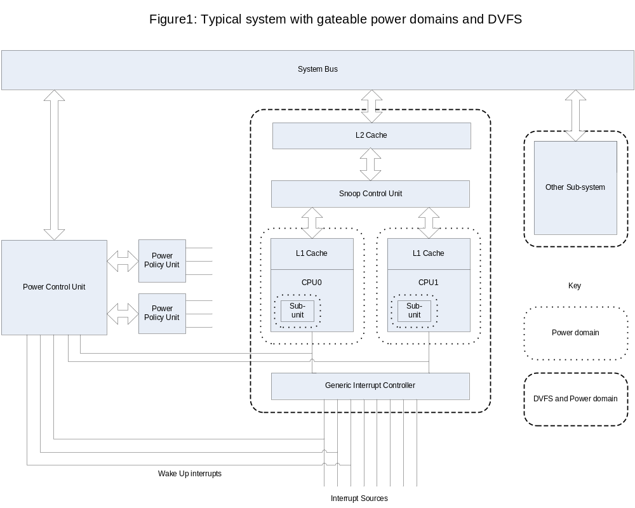

Levels of shutdown
Save and restore of context is the primary issue associated with power management. Where a volatile resource is to be powered down, context can be:
- Maintained in the quiescent state where the static power consumed by data retention circuits or properties inherent in the technology meet the power saving needs with respect to when the resource is operational.
- Saved to non-volatile memory as part of the shutdown procedure then restored prior to the resumption of execution on the resource. Saving can be hardware based, software based, or a combination thereof.
- Lost and the resource re-initialized on resumption where context is of temporal value only or has an in-built auto-recovery mechanism.

Power saving states - general
While the motivation for defining power states is driven by developing a consistent approach to power management through ARM cores, the intent is that the architected power states can apply to:
- Sub-blocks of functionality within a CPU – for example a sub-block for the Advanced SIMD Extension to provide NEON™ support
- CPUs within multiprocessing environments
- subsystems that might or might not include a processor core, e.g. a graphics subsystem
At any given level, power gating of a block requires:
- isolation (clamping) between resources gated OFF versus those where power is still applied
- clock gating between blocks in different power states
- reset provision between blocks to allow orderly start up of a block from a non-operational state
- control/status handshake signals to ensure correctness when a resource is taken out of service or re-introduced to a running environment.
The power states defined for the ARM architecture are illustrated in Table 1. In addition, different degrees of power saving within each power state can be implemented, differentiated by:
- the time taken to enter from or return to a Run state
- the amount of core and/or system logic that is taken to a low power state
- a combination of 1 and 2.

Table 1 General power states
Power  State | Name | Description
0 | Run | Operational states, by example a core that executes instructions
1 | Standby | Clocks are stopped but power is not removed and no state is lost. Restart is by the next instruction, transparent to software, and not through the reset vector.
2 | Sleep | Retention is provided for all cache and processor state. Retention of other logic that is powered down, or clock gating effects that occur beyond the core are SYSTEM DEFINED and outside the scope of this document. Restart can be transparent to software.
3 | Dormant | Retention is used for RAM only (caches and TCMs), processor logic is powered down. Processor context must be saved prior to power down. Restart is through the reset vector, and will require some hardware and/or software intervention to restore cache and TCM operation.
4 | Shutdown | All power is removed from the core and associated caches. Context that needs to be preserved must be saved to non-volatile memory before the power is removed. Restart is through the reset vector.
Notes:
Power states can be applied at different levels, for example:
- System
- Device
- CPU
- Sub-block
For the shutdown, dormant and sleep states, system designers need to ensure any accesses that can occur to powered-down logic (for example by a debugger) result in an error response rather than a lockup condition.

Different levels of power management and performance can be achieved for a given state through application and control of different parameters such as:
- applied voltage – Vcc for the domain
- bias voltage(s)
- clock frequency.

Cluster, CPU and Sub-unit power states
The following language is used to describe power domains with respect to a cluster of processors, where a cluster is defined as a group of processors compliant with the ARMv7-A architecture and its MP Extensions.
- Cluster: resources shared by the cluster that are managed within a cluster-wide power domain. By example, an SCU or a shared L2 cache
- CPU[n]: a processor within the cluster
- Sub-unit[n,m]: a feature within a CPU that is IMPLEMENTATION DEFINED or an ARMv7-A architecture option

The following power states are defined:
Table 2 Cluster power states
Cluster (L2+SCU) | CPU[n] | Sub-unit[n,m] | Notes
R | R | R | These three states form an independent state machine.  When a CPU enters D or S state, each Sub-unit enters the same state as the CPU, or remains in S if already there.  Warm boot of the CPU returns each Sub-unit to its previous power state, to reduce OS complexity.
R | R | D
R | R | S
R | r | - | Minimal core boot for firmware to save/clean Cluster context: used to transition between Dxx and Sxx.
R | D | - | The L1 data cache of a CPU in Dormant state cannot respond to snoop requests from the SCU. Hence Dormant state is only used for the last CPU, when the others are in Shutdown, unless the cache is cleaned and invalidated.
D | D | -
R | S | -
D | S | -
S | S | -
R = Running D = Dormant S = Shutdown r = minimal running environment

CPU and sub-block power state transition diagrams

Transition between the states defined in Table 2 on page 23 fall into two categories:
- Power state transitions for a sub-block within a running CPU
- Power state transitions of a CPU within a cluster

The state transitions of a sub-block are illustrated in .
The state transitions of a CPU within a cluster are illustrated in Figure 2.
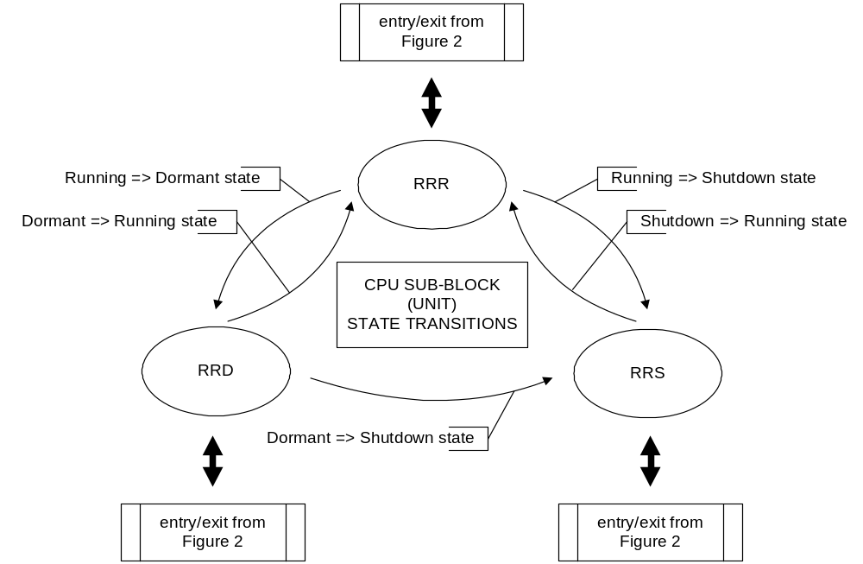

Figure 1 Power state transitions of a sub-block within a CPU

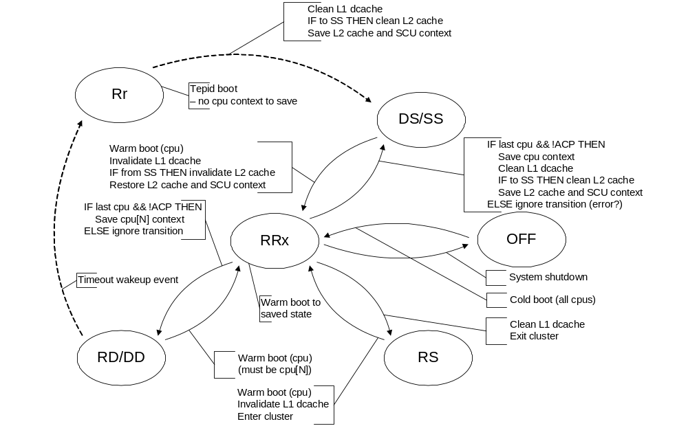
Figure 2 Power state transitions of a CPU within a cluster

Dormant mode, caches and coherency
The following general statements apply to the ARMv7 architecture and its support of dormant caches as part of a shareable memory domain:
- Any cache lines associated with a shareability domain that might be accessed while the cache is in Dormant state must be cleaned from the cache as part of its transition to Dormant state.
- Where data is retained in a cache in Dormant state, no active agent within the shareability domain can access that data.
- Any shareable memory locations held in a cache and modified by other agents while the cache is in Dormant state must be invalidated before the cache is re-enabled.
- It is IMPLEMENTATION DEFINED how domain coherency is re-established for a cache that rejoins a shareability domain from Dormant state.

ARM policy and dormant resources
ARM strongly recommends that a stricter approach to coherency is adopted for power management within a cluster as follows:
- A shareable memory resource (for example, a level 1 cache) is only supported in Dormant state where it is:
  - a unique resource – not in a coherent cluster
  - associated with a uniprocessor environment
  - associated with the last CPU executing within a cluster.
If a CPU is not the last executing CPU, its shareable memory resources must be taken to a state (clean or invalid) that can be treated as if Shutdown on a warm boot.

Power gating and the Security Extensions
The Security Extensions introduce an address space hierarchy into the ARM architecture:
- A Secure address space entered on system reset
- A Non-secure address space administered by the Secure environment
To avoid QoS and security issues, the privilege hierarchy must be involved in any decision to remove power from a running core, or the core must have limited scope to control the depth of power-down. Designs that use the Security Extensions must have a global enable bit (or logical equivalent) at a Secure location in the power controller. The bit is used to qualify the assertion of the STANDBYWFI signal to a power controller.
While the hierarchy in the ARM architecture is that Secure software has overall control, some usage models have the Secure software acting as a child under the Non-secure software environment. In these cases, it might be desirable to minimise use of the Secure state in the power saving and restore processes. Secure Monitor Calls (SMC instructions) can be used to communicate commands and responses between the Secure and Non-secure software environments where required by software, for example:
- NS => S: Clean and disable L1$Dcache – required prior to leaving an SMP cluster
- NS => S: Notice of intent - Dormant mode shutdown request
  - S-side responds OK when NS-side clear to proceed and issue the necessary WFI
- NS => S: Command - Dormant mode shutdown request
  - S-side saves its own and NS (banked) state then initiates the shutdown.
An alternative approach is that the Secure address space and associated software is configured such that it is always re-entrant from reset after control has transferred to the Non-secure address space. In this case, any critical Secure events that are independent of the Non-secure execution environment must be configured as wakeup events at the system level.
The firmware solution will document the usage models supported and any system dependencies.

Effect of the CP15SDISABLE input
The ARM architecture Security Extensions define the CP15SDISABLE input signal. The signal allows an implementation to suppress writes to Secure registers until the mechanism is reset. A context restore policy must consider the implications of the CP15SDISABLE signal, and its affect on register access from a Non-secure address space.

Jazelle support
Coprocessor 14 provides three architecturally visible registers to support the Jazelle architecture extension:
- the Jazelle ID register (JIDR, read only)
- the Jazelle Main Configuration Register (JMCR)
- the Jazelle OS Control Register (JOSCR).
Restoration of Jazelle state, including these registers, is the responsibility of a Jazelle-aware operating system or Java Virtual Machine (JVM). None of the Jazelle registers are saved or restored by the firmware. Any Jazelle support must be reset in systems that do not offer full hardware retention.

Debug support
Debug introduces additional issues that need to be considered in a power cycling environment:
- Does the debugger need to debug software associated with saving and restoring context on a power cycle?
- Does the debugger need to connect to a live system and auto-detect it at a point in time where the processor (core) may be powered down?
- Does the debugger need to remain connected across a power cycle?
- Should the power cycle be emulated rather than activated where debug is required?
- Power domain requirements in a system supporting debug and power control.
The ARMv7 debug architecture and the associated recommended ARM Debug Interface (ADIv5) along with the CoreSight system debug architecture have included provision for debug and power control.
The most transparent form is to emulate power cycling in an implementation using the DBGNOPWRDWN signal. An optional ARMv7 OS lock mechanism that uses an OS Save and Restore Register (DBGOSSRR) for saving and restoring debug specific context is described in the ARMv7-AR architecture. However, a division of registers between the debug and core power domains with a direct approach to save and restore of the context is now favoured as the general approach over the longer term.

Performance monitor support
The ARM architecture supports cycle and event counters for profiling and other uses. The feature can be treated as an independent entity from debug for save and restore reasons. In particular, the impact of the save and restore code on the recorded information is a software system design decision.

Appendix: The Context Save and Restore Code

Before entry to Shutdown or Dormant state, processor and system state must be saved. When power is applied to the domain, the context must be restored.
Conceptually, the sequence for a single processor entering Dormant or Shutdown state is:

Disable_all_external_requestors() ; inhibit interrupts, memory (TCM) accesses,
; or debug events that could wake up the core
Save_CPU_context_in_memory()
Save_SysCache_context_in_memory() ;
Set_WARMSTART_Marker_in_memory() ; flag for reset handler on wake up
DSB;
Cache_Sync() ; Ensure system cache is idle with all transactions complete
DSB;
WFI;
Once the CPU has entered WFI state, the power controller may remove power from the CPU.

Restoration is then via reset – the reset handler sequence is:
Load_WARMSTART_Marker();
if WARMSTART == FALSE then
HardResetSequence();
else
Restore_System_context_from_memory(); Order with respect to the CPU
; ...is SYSTEM DEFINED
Restore_CPU_context_from_memory();
Re-enable_external_requestors();

